**Period Instruments**

**Baroque Violin**

Development

The violin was developed during the 16th century. Different sizes made up a family or consort of instruments—violin, viola, cello, and bass. Around 1660 the size of violins became standardized.

Bows

Bows went through significant changes during the Baroque era. They became longer in the 18th century to accentuate the modern legato style of playing. Baroque bows are generally straight or bent slightly outwards whereas modern bows are bent inwards.

Baroque bows are typically built from strong snakewood and modern bows are made from lightweight pernambuco.

Chin Rests

Baroque violins do not have a chin rest or shoulder rest and are typically held against the left side of the chest which made it hard to shift fingerings. The chin rest and shoulder rest which are on modern violins were not invented until the 19th and 20th century respectively.

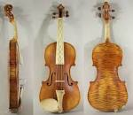

**Lute**

General

The term “lute” refers generally to any plucked string instrument with a neck and a round back. The lute has been used in a wide range of music, most commonly from the Medieval to the late Baroque eras. The lute was considered the most important instrument for secular music in the Renaissance.

Design and Use

Lutes are made entirely of wood and have up to 26–35 strings. The origin of the lute is not known, but it is thought that it was brought to Europe from the Middle East.

Lutes stopped being used after 1800 when they were replaced by keyboard instruments.

Notation

Improvisational playing was very important for lute players and much of the lute repetoire was never written down.

Lutenists read from a tablature—a special notation just for the lute that describes the position of the fingers on the instrument.

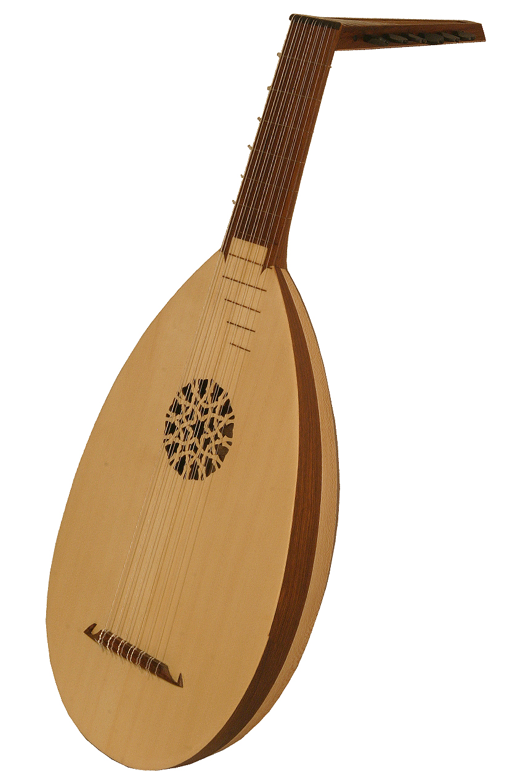

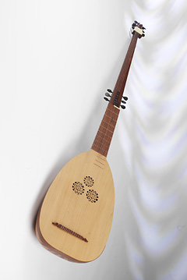

**Theorbo**

Theorbos are plucked string instruments of the lute family. They have an extended neck and a second pegbox, employing many more strings than the simple lute.

Theorbos were developed in the late 16th century in Italy.

They answered a demand for extended bass range instruments for use in opera.

Theorbos were often paired with small pipe organs and

were widely used in orchestral and chamber music until the mid-18th century.

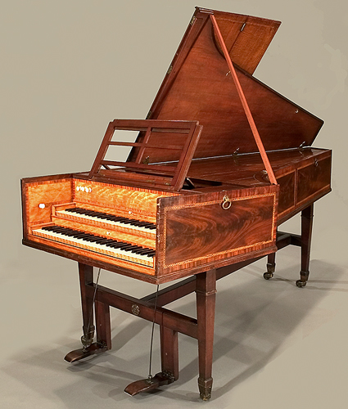

**Harpsichord**

Uses

Harpsichords were widely used in Renaissance and Baroque music.They gradually lost popularity in the late 18th century with the rise in popularity of the fortepiano.

Types

The term harpsichord encompasses several instruments played by means of a keyboard that engages a plucking mechanism. The family of haprsichords includes virginals, spinets, clavicytherium, clavicymbalum, and ottavino. Harpsichords come in all shapes and sizes and are unique to the maker of the instrument.

Development

Harpsichords were probably invented in the Middle Ages but the majority of music written for them was composed during the Renaissance and Baroque periods. The first music written for the solo harpsichord was composed in the early 16th century. The most famous composer for the harpsichord is J.S. Bach (1685–1750)

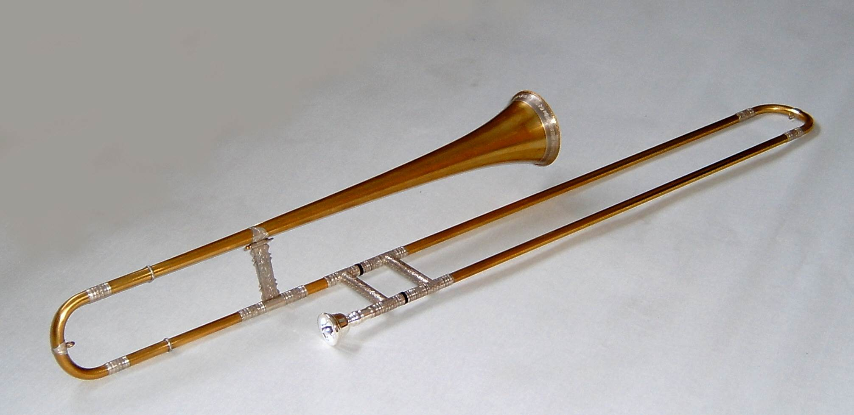

**Sackbut**

Design

Sackbuts are early trombones from the Renaissance and Baroque eras. Like a modern trombone, the sackbut’s defining feature is the slide that is used to vary the length of the instrument, resulting in a change of pitch. Contrasted with the modern trombone, the sackbut has a smaller bore size, a less-flared bell, and does not have a waterkey or slide lock. The sackbut is thought to have developed from the Renaissance slide trumpet.

In keeping with the expanding size of the orchestra, since the 19th century bore sizes and bells have increased in size. There are three main sizes of sackbuts (alto, tenor, bass), corresponding to the ranges of the voice.

Sound and Uses

The sound of the sackbut is typically described as delicate and having a vocal timbre.

Sackbuts often play together with the cornetto, the soprano instrument of the brass consort. Sackbuts are typically played with vocal ensembles in church settings or with other wind instruments for outdoor entertainments.